1 Connecting to Microsoft SQL Server 2
2 Table Schemas 4
2.1 Notes 4
2.2 tblCustomer 4
2.3 tblOrder 5
2.4 tblOrderLine 6
2.5 tblCreditMemoMaster 7
2.6 tblCreditMemoDetail 8
2.7 tblSourceCode 9
2.8 tblCustomerOffer 10
2.9 tblDate 11
2.10 tblSKU 12
2.11 tblVendor 13
2.12 tblVendorSKU 14
2.13 tblPGC 15
2.14 tblMarket 16
2.15 tblDate 17
2.16 tblTime 18
2.17 tblGiftCard 19
2.18 tblSKUTransaction 20
2.19 tblEmployee 21
2.20 tblTimeClock 22
2.21 tblJobClock 23
2.22 tblDropship 24
2.23 tblCatalogMaster 25
2.24 tblCatalogDetail 26
2.25 tblPOMaster 27
2.26 tblPODetail 28
2.27 tblReceiver 29
2.28 tblBOMTemplateMaster 30
2.29 tblBOMTemplateDetail 31
2.30 tblBOMTransferMaster 32
2.31 tblBOMTransferDetail 33
3 Sample Queries 34
3.1 Sales of (shipped) SKUs for a given catalog 34
3.2 Sales by Account Manager – Shipped/Invoice Only 35
3.3 Sales By Customer (Shipped) for a Given Date Range 36
3.4 Merchandise Returns/Credited by Customer – Aggregated By Customer for Date Range 38

Connecting to Microsoft SQL Server
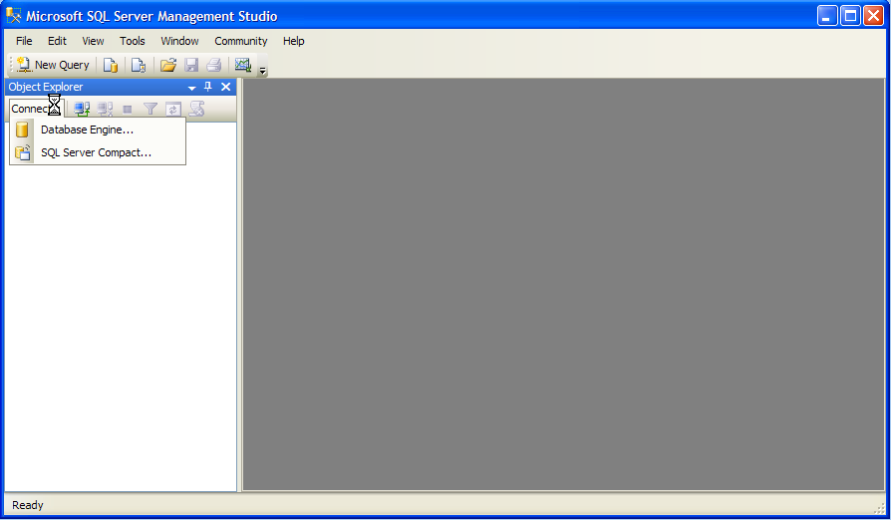

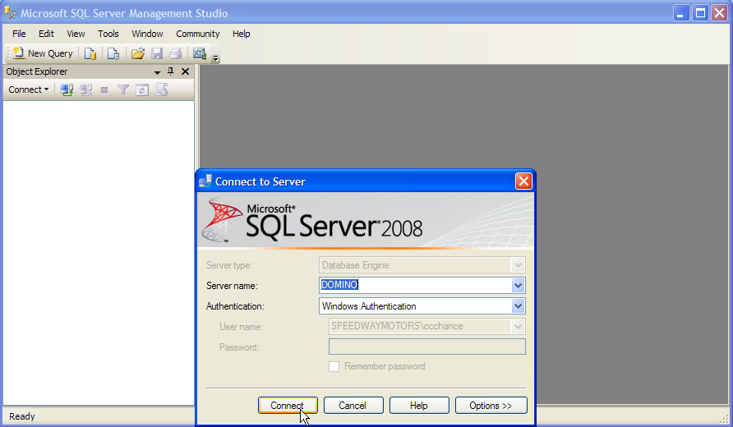
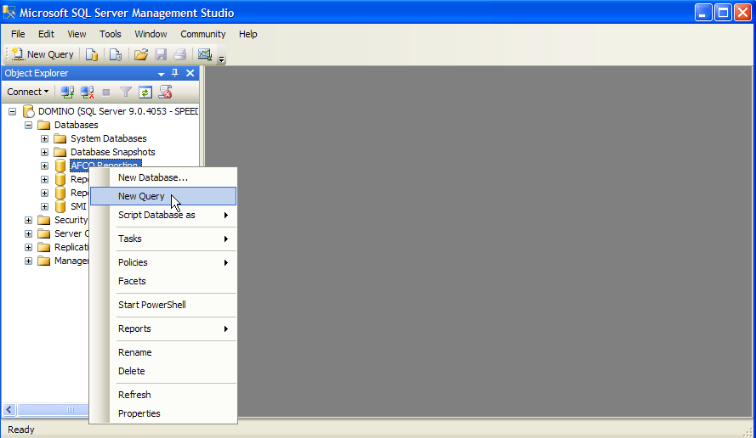

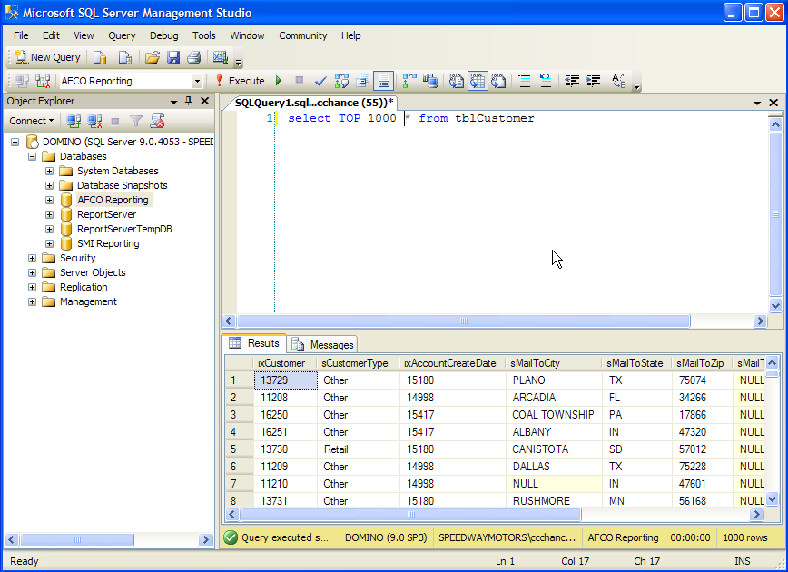

Table Schemas

Notes
Column names use a modified hungarian notation.
The prefix indicates the purpose of the column, it does not define the datatype.
SQL Operations - Order of Precedence
- FROM clause
- WHERE clause
- GROUP BY clause
- HAVING clause
- SELECT clause
- ORDER BY clause

tblCustomer

Master customer table

Column | Datatype | Description
ixCustomer | Int | Primary key to customer table (and customer#)
sCustomerType | Varchar(10) | Customer type (Retail, PRS, MRR, Other)
ixAccountCreateDate | Smallint | Foreign key to tblDate. Date account created
sMailToCity | Varchar(25) | Catalog mailto city
sMailToState | Varchar(20) | Catalog mailto state
sMailToZip | Varchar(15) | Catalog mailto country
ixSourceCode | Varchar(15) | Foreign key to tblSourceCode. Source code used to create account
dtAccountCreateDate | Datetime | User-friendly version of ixAccountCreateDate

tblOrder

Master order table. Contains all orders entered in SOP – i.e. shipped, backordered, open, cancelled.

Column | Datatype | Description
ixOrder | Varchar(10) | Primary key to order table (and order#)
ixCustomer | Int | Foreign key to tblCustomer. Customer#
ixOrderDate | Smallint | Foreign key to tblDate. Date order entered
sShipToCity | Varchar(25) | Shipto city
sShipToState | Varchar(20) | Shipto state
sShipToZip | Varchar(15) | Shipto zip
sOrderType | Varchar(20) | Order type (PRS, MRR, Retail, etc.)
sOrderMethod | Varchar(10) | Order entry method (WEB, PHONE, MAIL, etc.)
sCountry | Varchar(30) | Shipto country
ixShippedDate | Smallint | Foreign key to tblDate. Date order first shipped
iShipMethod | Smallint | Shipping method (2,3,4, etc.)
sSourceCodeGiven | Varchar(15) | Source code given by customer
sMatchbackSourceCode | Varchar(15) | Source code assigned during matchback process
sMethodOfPayment | Varchar(15) | Method of payment (VISA, AMEX, etc.)
sOrderTaker | Varchar(10) | Person who entered order
sPromoApplied | Varchar(10) | Promotion code applied to order
mMerchandise | Smallmoney | Total $ value of merchandise on order
mShipping | Smallmoney | Shipping billed to customer
mTax | Smallmoney | Tax
mCredits | Smallmoney | Credits applied to order
sOrderStatus | Varchar(12) | Status of order (open, shipped, cancelled, etc.)
mMerchandiseCost | Smallmoney | Cost of merchandise on order
dtOrderDate | Datetime | User-friendly version of ixOrderDate
dtShippedDate | Datetime | User-friendly version of ixShippedDate
ixAccountManager | varchar(10) | Account manager for order
ixOrderTime | Varchar(20) | Time order taken. Foreign key to tblTime
mPromoDiscount | Smallmoney | Dollar value of promotion applied to order
ixAuthorizationStatus | Varchar(15) | Auth stats (OK, VA, etc.) foreign key to AuthorizationTypes tables.

tblOrderLine
Line level order information

Column | DataType | Description
ixOrder | varchar(10) | Foreign key to tblOrder (order#)
ixCustomer | int | Foreign key to tblCustomer (customer #)
ixSKU | varchar(30) | Foreign key to tblSKU (sku#)
ixShippedDate | smallint | Foreign key to tblDate. Date line shipped
ixOrderDate | smallint | foreign key to tblDate. Date line ordered
iQuantity | smallint | quantity ordered
mUnitPrice | smallmoney | Unit price ($)
mExtendedPrice | smallmoney | Extended price ($)
flgLineStatus | varchar(10) | Lost, Regular, Backordered
mUnitCost | smallmoney | Unit cost ($)
mExtendedCost | money | Extended cost ($)
dtShippedDate | datetime | User-readable format date
dtOrderDate | datetime | User-readable format date
mCost | Smallmoney | Unit cost
mExtendedCost | money | Extended cost ($)

tblCreditMemoMaster
Column | Datatype | Description
ixCreditMemo | varchar(10) | primary key
ixCustomer | varchar(10) | foreign key to customer table
ixOrder | varchar(10) | foreign key to order table
ixCreateDate | smallint | foreign key to date table
sOrderChannel | varchar(10) | order channel
mMerchandise | smallmoney | merchandise
sMemoType | varchar(10) | Refund / Exchange
dtCreateDate | datetime | User-readable format date

tblCreditMemoDetail
Column | Datatype | Description
ixCreditMemoLine | int | primary key (auto inc)
ixCreditMemo | varchar(10) | foreign key to credit memo table
ixSKU | varchar(50) | foreign key to SKU table
iQuantityReturned | smallint | quantity returned
iQuantityCredited | smallint | quantity credited
mUnitPrice | smallmoney | unit price of sku (from order)
mUnitCost | smallmoney | unit cost of sku (from order)
sReturnType | varchar(10) | return reason (rtv, ret, etc.)

tblSourceCode
Column | DataType | Description
ixSourceCode | varchar(15) | source code
ixStartDate | smallint | start date for source code - foreign key to tblDate
ixEndDate | smallint | end date for source code - foreign key to tblDate
ixCatalog | varchar(15) | Catalog code
sDescription | varchar(30) | Description
sCatalogMarket | varchar(10) | catalog market
dtStartDate | datetime | User-readable format date
dtEndDate | datetime | User-readable format date

tblCustomerOffer
Column | Datatype | Description
ixCustomerOffer | int | auto increment key for table
ixCreateDate | smallint | create date
ixActiveStartDate | smallint | date offer (source code) is active for customer
ixActiveEndDate | smallint | date offer (source code) becomes inactive
sType | varchar(15) | offer type (mailing, insert, etc.)
ixSourceCode | varchar(15) | source code (offer)
ixCustomer | int | customer#
dtCreateDate | datetime | User-readable format date
dtActiveStartDate | datetime | User-readable format date
dtActiveEndDate | datetime | User-readable format date

tblDate
Column | Datatype | Description
ixDate | smallint | primary key to tblDate table. (auto inc)
dtDate | datetime | User-readable format date
iQuarter | tinyint | Quarter (1..4) for date dDate
iPeriod | tinyint | Accounting Period for date dDate
iWeek | tinyint | Week of year
iDayOfWeek | tinyint | 1..7
iDayOfYear | smallint | 1..365/6
iYear | smallint | year in yyyy format
iPeriodYear | smallint | Accounting year (for accounting period iPeriod)

tblSKU
Column | Datatype | Description
ixSKU | varchar(30) | primary key
mPriceLevel1 | smallmoney | Level 1 inventory price
mPriceLevel2 | smallmoney | Level 2 inventory price
mPriceLevel3 | smallmoney | Level 3 inventory price
mPriceLevel4 | smallmoney | Level 4 inventory price
mPriceLevel5 | smallmoney | Level 5 inventory price
mLatestCost | smallmoney | Latest cost
mAverageCost | smallmoney | Average Cost
ixPGC | varchar(5) | foreign key to tblProductGroupCode
sDescription | varchar(30) | SKU description
flgUnitOfMeasure | varchar(5) | Unit of measurement
flgTaxable | tinyint | charge tax on SKU
iQAV | smallint | quantity available
iQOS | smallint | quantity on shelf
ixCreateDate | smallint | Key to tblDate
dtCreateDate | datetime | User readable date
ixRoyaltyVendor | Varchar(10) | Foreign key to vendor. Indicates the recipient of any royalty payments for sales of part.
ixDiscontinuedDate | smallint | Key to tblDate
dtDiscontinuedDate | datetime | User readable date
flgActive | tinyint | Flag indicating whether item is discontinued or active
dWeight | decimal(4,3) | weight of item
sOriginalSource | Varchar(30) | Original source for unique part

tblVendor
Column | Datatype | Description
ixVendor | varchar(10) | vendor#
sName | varchar(30) | vendor name
sCity | varchar(30) | vendor city
sState | varchar(30) | vendor state
sZip | varchar(10) | vendor zip code

tblVendorSKU
Column | Datatype | Description
ixPrimaryKey | int | auto increment primary key
sVendorSKU | varchar(30) | Vendor sku
ixSKU | varchar(30) | foreign key to tblSKU
ixVendor | varchar(5) | Vendor#
mCost | smallmoney | current cost for vendor
iOrdinality | tinyint | ordinality for sku/vendor
iLeadTime | smallint | Lead time for ordering SKU (in days)

tblPGC
Column | Datatype | Description
ixPGC | varchar(5) | primary key to tblProductGroupCode
ixMarket | varchar(5) | foreign key to market table

tblMarket
Column | Datatype | Description
ixMarket | varchar(5) | primary key to tblMarket
sDescription | varchar(25) | description of market

tblDate
Column | Datatype | Description
ixDate | int | primary key tblDate
dtDate | datetime | User-readable format date
iYear | int | year
iMonth | int | month
iDayOfWeek | smallint | day of week
iDayOfMonth | smallint | day of month
iAccountingPeriod | smallint | accounting period (based on 4-5-4)
iAccountingYear | smallint | year associated with accounting period

tblTime
Column | Datatype | Description
ixtime | int | primary key to tblTime
tTime | time | time
iHour | smallint | hour of day
iMinute | smallint | minute of hour
iSecond | smallint | second of minute
iInterval15 | smallint | # of 15 minute interval represented by time

tblGiftCard
Column | Datatype | Description
ixGiftCard | int | primary key to gift card table
ixPurchaseOrder | varchar(10) | foreign key to tblOrder
mOriginalValue | smallmoney | original $ value of gift card
mPurchaseAmount | smallmoney | $ paid for gift card
ixPurchaseDate | smallint | foreign key to tblDate
dtPurchaseDate | datetime | User-readable format date

tblSKUTransaction
Column | Datatype | Description
ixDate | smallint | foreign key to tblDate
ixTime | int | foreign key to tblTime
sUser | varchar(10) | user who performed transaction
iSeq | int | sequence in day's transactions
sTransactionType | varchar(20) | transaction type
ixSKU | varchar(30) | foreign key to tblSKU
iQty | smallint | Transaction quantity
mAverageCost | money | average cost
sLocation | varchar(5) | Location
sToLocation | varchar(5) | to location
sWarehouse | varchar(15) | Warehouse
sToWarehouse | varchar(15) | to warehouse
sBin | varchar(20) | bin
sToBin | varchar(20) | to bin
sCID | varchar(15) | CID
sToCID | varchar(15) | to CID
sGID | varchar(15) | GID
sToGID | varchar(15) | to GID
ixReceiver | Varchar(10) | Foreign key to receiver

tblEmployee
Column | Datatype | Description
ixEmployee | varchar(10) | qop id for employee
sLastname | varchar(20) | employee last name
sFirstname | varchar(20) | employee first name

tblTimeClock
Column | DataType | Description
ixTimeClock | int | auto inc key
ixDate | smallint | date
ixEmployee | varchar(10) | qop id for employee
ixTime | int | number of seconds spent on the clock
dtDate | datetime | User-readable format date

tblJobClock
Column | DataType | Description
ixJobClock | int | auto inc key
ixDate | smallint | date
iStartTime | int | time job was started
iStopTime | int | time job was finished
sJob | varchar(50) | job description
ixEmployee | varchar(10) | qop id of employee
dtDate | datetime | User-readable format date

tblDropship
Column | DataType | Description
ixDropship | int | auto inc key
ixSpecialOrder | varchar(10) | Key to spord file
iQty | int | Quantity of part
sDescription | varchar(30) | Description of part
ixSKU | varchar(30) | SKU number
ixOrder | varchar(10) | order number
ixVendor | varchar(5) | vendor number
mCost | smallmoney | cost of part
mPrice | smallmoney | retail price of part
mShippingCharge | smallmoney | cost to ship from vendor to customer
sCity | varchar(30) | shipping city
sState | varchar(30) | shipping state
sZip | varchar(10) | shipping zip
ixConfirmedShipDate | smallint | date dropship was confirmed
ixExpectedShipDate | smallint | date dropship is expected to ship
ixActualShipDate | smallint | date dropship did ship
ixEmailDate | smallint | date email was sent to vendor
ixEmailTime | int | time email was sent to vendor
dtConfirmedShipDate | datetime | User-readable format date
dtExpectedShipDate | datetime | User-readable format date
dtActualShipDate | datetime | User-readable format date
dtEmailDate | datetime | User-readable format date

tblCatalogMaster
Column | DataType | Description
ixCatalog | Varchar(10) | Catalog id
sDescription | Varchar(20) | Catalog description
sMarket | Varchar(10) | Primary market of catalog
ixStartDate | Smallint | Foreign key to date table. Start date of catalog
ixEndDate | Smallint | Foreign key to date table. Expiration date of catalog
dtStartDate | Datetime | User-friendly version of ixStartDate
dtEndDate | Datetime | User-friendly version of ixEndDate

tblCatalogDetail
Column | DataType | Description
ixCatalog | Varchar(10) | Catalog id
ixSKU | Varchar(30) | SKU (foreign key to tblSKU)
mPriceLevel1 | Smallmoney | Level 1 catalog price
mPriceLevel2 | Smallmoney | Level 2 catalog price
mPriceLevel3 | Smallmoney | Level 3 catalog price
mPriceLevel4 | Smallmoney | Level 4 catalog price
mPriceLevel5 | Smallmoney | Level 5 catalog price
I1stPage | Int | 1st appearance of SKU in catalog
I2ndPage | Int | 2nd appearance of SKU in catalog
I3rdPage | Int | 3rd appearance of SKU in catalog
I4thPage | Int | 4th appearance of SKU in catalog
I5thPage | Int | 5th appearance of SKU in catalog
I6thPage | Int | 6th appearance of SKU in catalog
I7thPage | Int | 7th appearance of SKU in catalog
dSquareInches | Decimal(10,3) | total square inches of SKU

tblPOMaster
Column | DataType | Description
ixPO | Varchar(10) | Foreign key to tblPO
ixPODate | Smallint | Creation date
ixIssueDate | Smallint | Issue date
ixIssuer | Varchar(20) | Issuer
ixBuyer | Varchar(20) | Buyer
ixVendor | Varchar(20) | Vendor
sShipToName | Varchar(35) | Ship to name
sShipToAddress1 | Varchar(35) | Ship to address 1
sShipToAddress2 | Varchar(35) | Ship to address 2
sShipToCSZ | Varchar(35) | Ship to City, state, zip
sShipVia | Varchar(30) | Ship method
sPaymentTerms | Varchar(30) | Payment terms
sFreightTerms | Varchar(30) | Freight terms
Notes | Varchar(200) | Notes (not used)
flgBlanket | Tinyint | Blanket PO flag
sBillToName | Varchar(35) | Bill to name
sBillToAddress1 | Varchar(35) | Bill to address 1
sBillToAddress2 | Varchar(35) | Bill to address 2
sBillToCSZ | Varchar(35) | Bill to city state zip
sMessage1 | Varchar(55) | Message line 1
sMessage2 | Varchar(55) | Message line 2
sMessage3 | Varchar(55) | Message line 3
sMessage4 | Varchar(55) | Message line 4
sMessage5 | Varchar(55) | Message line 5
sEmailAddress | Varchar(50) | Email address

tblPODetail
Column | DataType | Description
ixPO | Varchar(10) | Catalog id
ixSKU | Varchar(30) | SKU (foreign key to tblSKU)
iQuantity | Smallint | Quantity
ixUnitofMeasurement | Varchar(10) | Unit of measurement
mCost | Smallmoney | Cost
iOrdinality | Smallint | Ordinality
ixExpectedDeliveryDate | Smallint | Expected delivery date
iQuantityReceivedPending | Smallint | Quantity received pending
iQuantityPosted | Smallint | Quantity posted

tblReceiver
Column | DataType | Description
IxReceiver | Varchar(10) | Foreign key to tblReceiver
ixCreateDate | Smallint | Foreign key to tblDate
ixCreateTime | Int | Foreign key to tblTime
ixCreateUser | Varchar(10) | Foreign key to tblEmployee
ixLastUpdateDate | Smallint | Foreign key to tblDate
ixLastUpdateTime | Int | Foreign key to tblTime
IxLastUser | Varchar(10) | Foreign key to tblEmployee
ixVendor | Varchar(10) | Foreign key to tblVendor
ixPO | Varchar(10) | Foreign key to tblPO
ixOnDockDate | Smallint | Foreign key to tblDate
ixOnDockTime | Int | Foreign key to tblTime
flgStatus | Varchar(10) | Open, closed or posted

tblBOMTemplateMaster
Column | DataType | Description
IxFinishedPartNumber | Varchar(30) | Foreign key to tblSKU
ixCreateDate | Smallint | Foreign key to tblDate
ixCreateUser | Varchar(10) | Foreign key to tblEmployee
ixUpdateDate | Smallint | Foreign key to tblDate
ixUpdateUser | Varchar(10) | Foreign key to tblEmployee
iFactor | Smallint | Multiplier of finished part quantity

tblBOMTemplateDetail
Column | DataType | Description
IxFinishedPartNumber | Varchar(30) | Foreign key to tblSKU
ixSKU | Varchar(30) | Component
iQuantity | Smallint | Component quantity

tblBOMTransferMaster
Column | DataType | Description
IxTransferNumber | Varchar(20) | BOM transfer #
ixFinishedPartNumber | Varchar(30) | Foreign key to tblSKU
iQuantity | Smallint | Quantity requested
iCompletedQuantity | Smallint | Quantity completed
flgReverseBOM | Bit | Reverse BOM flag

tblBOMTransferDetail
Column | DataType | Description
IxTransferNumber | Varchar(20) | BOM transfer #
ixSKU | Varchar(30) | Foreign key to tblSKU
iQuantity | Smallint | Component quantity

Sample Queries

Sales of (shipped) SKUs for a given catalog

/* sales of skipped skus fors a given catalog */
select
tblSKU.ixSKU as 'SKU',
tblSKU.sDescription as 'Description',
tblSKU.ixPGC as 'Product Group Code',
sum(tblOrderLine.iQuantity) as 'Quantity Sold',
sum(tblOrderLine.mExtendedPrice) as 'Extended Price',
sum(tblOrderLine.mExtendedCost) as 'Extended Cost'
from
tblOrderLine
right join tblSKU on tblOrderLine.ixSKU = tblSKU.ixSKU
left join tblOrder on tblOrderLine.ixOrder = tblOrder.ixOrder
left join tblSourceCode on tblOrder.sSourceCodeGiven = tblSourceCode.ixSourceCode
where
tblSourceCode.ixCatalog = 'REB09'
and
tblOrderLine.flgLineStatus = 'Shipped'
and
tblOrderLine.dtShippedDate between '03/01/09' and '06/01/09'
group by
tblSKU.ixSKU,
tblSKU.sDescription,
tblSKU.ixPGC
order by
sum(tblOrderLine.iQuantity) desc

Sales by Account Manager – Shipped/Invoice Only

/** Sales by Account Manager - Shipped/Invoice Only
(excludes backordered/open/cancelled lines)
for a given date range
*/

select
tblCustomer.ixAccountManager as 'Account Manager',
tblOrder.ixCustomer as 'Customer#',
tblCustomer.sCustomerFirstName as 'Firstname',
tblCustomer.sCustomerLastName as 'LastName',
count(distinct tblOrder.ixOrder) as 'Orders',
sum(tblOrder.mMerchandise) as 'Revenue',
sum(tblOrder.mMerchandiseCost) as 'Cost'

from
tblOrder
left join tblCustomer on tblOrder.ixCustomer = tblCustomer.ixCustomer
where
tblOrder.dtShippedDate >= '02/01/10'
and
tblOrder.dtShippedDate < '03/01/10'
and
(tblOrder.sOrderStatus = 'Shipped' or tblOrder.sOrderStatus = 'Open')
and
tblCustomer.ixAccountManager is not null
group by
tblCustomer.ixAccountManager,
tblOrder.ixCustomer,
tblCustomer.sCustomerFirstName,
tblCustomer.sCustomerLastName

Sales By Customer (Shipped) for a Given Date Range

The following query provides sales (shipped lines) by customer for a given date range. Note that the query aggregates order-line level detail to generate merchandise cost and revenue.
/* sales by customer (shipped) for a given date range */

select
tblCustomer.ixCustomer as 'Customer#',
tblCustomer.sCustomerLastName as 'Lastname',
tblCustomer.sCustomerFirstName as 'Firstname',
sum(tblOrderLine.mExtendedPrice) as 'Revenue',
sum(tblOrderLine.mExtendedCost) as 'Cost'
from
tblOrderLine
left join tblCustomer on tblOrderLine.ixCustomer = tblCustomer.ixCustomer
where
tblOrderLine.flgLineStatus = 'Shipped'
and
tblOrderLine.dtShippedDate >= '02/01/10'
and
tblOrderLine.dtShippedDate < '03/01/10'
group by
tblCustomer.ixCustomer,
tblCustomer.sCustomerLastName,
tblCustomer.sCustomerFirstName
Merchandise Returns By Customer – Line-level detail, sorted by customer, by part

/* merchandise returns by customer
credit memo line-level detail
*/

select
tblCreditMemoMaster.ixCustomer as 'Customer#',
tblCustomer.sCustomerLastName as 'Lastname',
tblCustomer.sCustomerFirstName as 'Firstname',
tblCreditMemoDetail.ixSKU as 'SKU Returned',
tblCreditMemoDetail.iQuantityCredited as 'Qty Credited',
tblCreditMemoDetail.iQuantityReturned as 'Qty Returned',
tblCreditMemoDetail.mUnitPrice as 'Unit Price',
tblCreditMemoDetail.mUnitCost as 'UnitCost',
convert(varchar, tblCreditMemoMaster.dtCreateDate, 101) as 'Credit Date'
from
tblCreditMemoDetail
left join tblCreditMemoMaster on tblCreditMemoDetail.ixCreditMemo = tblCreditMemoMaster.ixCreditMemo
left join tblCustomer on tblCreditMemoMaster.ixCustomer = tblCustomer.ixCustomer
where
tblCreditMemoMaster.dtCreateDate >= '01/01/10'
and
tblCreditMemoMaster.dtCreateDate < '04/01/10'
order by
tblCreditMemoMaster.ixCustomer

Merchandise Returns/Credited by Customer – Aggregated By Customer for Date Range

/* returned/credited merchandise by customer, for given date range */

select
tblCreditMemoMaster.ixCustomer as 'Customer#',
sum(tblCreditMemoDetail.iQuantityReturned) as 'Qty Returned',
sum(tblCreditMemoDetail.iQuantityCredited) as 'Qty Credited',
sum(tblCreditMemoDetail.mUnitPrice * tblCreditMemoDetail.iQuantityReturned) as 'Merch Returned Revenue',
sum(tblCreditMemoDetail.mUnitCost * tblCreditMemoDetail.iQuantityReturned) as 'Merch Returned Cost',
sum(tblCreditMemoDetail.mUnitPrice * tblCreditMemoDetail.iQuantityCredited) as 'Merch Credited Revenue',
sum(tblCreditMemoDetail.mUnitCost * tblCreditMemoDetail.iQuantityCredited) as 'Merch Credited Cost'
from
tblCreditMemoDetail
left join tblCreditMemoMaster on tblCreditMemoDetail.ixCreditMemo = tblCreditMemoMaster.ixCreditMemo
where
tblCreditMemoMaster.dtCreateDate between '03/01/10' and '03/31/10'
group by
tblCreditMemoMaster.ixCustomer

